**GROUP PROJECT AIMS**

**GROUP MEMBERS**

|  |  |  |  |
| --- | --- | --- | --- |
| Sn | Name | Name of Institution | Role played in project |
| 1 | Geraldo Isaaks  (Team Captain) | International Training College - Lingua |  |
| 2 | Anthony Bock  (Team Leader) | International Training College - Lingua | Backend Developer |
| 3 | Jens Griebel | International Training College - Lingua | Backend Developer |
| 4 | Mark Beukes | International Training College - Lingua | Frontend Developer |
| 5 | Christo de Wee | International Training College - Lingua | Frontend Developer |
| 6 | Geo-Aldro Theron | International Training College - Lingua | Frontend Developer |

**Table of Content**

1. TABLE OF CONTENT: ……………………………………………………………. 1
2. DESCRIPTION OF PROJECT: …………………………………………….……. 2
3. FUNCTIONALITIES PROVIDED BY THE SOFTWARE: ………….……. 2
4. FLOWCHARTS: ……………………………………………..………………………. 3
5. PROGRAMMING LANGUAGES/TOOLS USED: ………………….……. 4
6. SOURCE CODES OF THE PROGRAM: (HTML & CSS): ……………… 5
7. SCREEN SHOTS OF THE SOFTWARE/DATABASE: ……………………. 8
8. CONCLUSION: ………………………………………………………………………. 9
9. **DESCRIPTION OF PROJECT:**



**Introduction/Description:**

**High Table** is a platform designed for individuals and businesses. It allows users to create profiles highlighting their work experience, skills, and education. Users can connect with others in their industry, join professional groups, and share content related to their careers. High Table serves as a hub for job searching, recruitment, business development, and knowledge sharing in the professional world.

High Table is a comprehensive online platform primarily centered around career development and career advice.

At its core, High Table allows users to create detailed personal profiles that resemble digital resumes. These profiles include information about one's work history, education, skills, and endorsements, providing a comprehensive snapshot of a user's professional background. Users can also upload a profile picture and write a summary to further personalize their online identity.

1. **FUNCTIONALITIES PROVIDED BY THE SOFTWARE:**

|  |  |
| --- | --- |
| **Functionality** | **Description** |
| Profile Creation/ Registration | Users can create profiles highlighting name, surname, email, and more. |
| Job Placement | Search and apply for job openings, receive job recommendations. |
| Career Advice | Discover customized learning paths and courses for skill development. |
| Company News | Global Breaking News regarding the business world. New technology advancements and simply entertainment news. |
| Feedback | Provide a direct channel for users to express their opinions, concerns and suggestions related to the application. |

1. **FLOWCHART:**

User sees the “Profile” button

User sees the “Profile” button

Redirect to the respective pages

User clicks “Sign up” or “Login”

Perform a search

User enters a search query

User interacts with various content sections

End

User clicks the “Profile” button

User opens the “Home page” of the application

Start

1. **PROGRAMMING LANGUAGES/TOOLS USED:**

**Programming languages used:** Python, HTML, CSS

**Platform Used:** Replit, Adobe Dreamweaver, Apache NetBeans and VS Code

**Database Used**: sqlalchemy

1. **SOURCE CODES OF THE PROGRAM: (HTML & CSS):**

**CODE 1:**

<!doctype html>

<html>

<head>

<meta charset="utf-8">

<meta name="viewport" content="width=device-width, initial-scale=1, shrink-to-fit=no">

<title>Login</title>

</head>

<link rel="stylesheet" href="Login.css">

<body>

<div class="container">

<img src="images/Logo.png" width="396" height="311" alt=""/>

<div>

<label for="uID"><b>UserID</b></label>

<input type="text" placeholder="Enter UserID" name="uID" required>

<label for="psw"><b>Password</b></label>

<input type="password" placeholder="Enter Password" name="psw" required>

<input type="submit" value="Login">

<input type="submit" value="Sign Up">

<a class="a" href="">Forgot Password</a>

</div>

</div>

<script>

</script>

</body>

</html>

**CODE 2:**

<!doctype html>

<html>

<head>

<meta charset="utf-8">

<title>JobPlacement</title>

<link rel="stylesheet" href="Ethics,Interview,Resume.css">

</head>

<body>

<button class="collapsProfile">

</button>

<div class="contentProfile">

<div class="ProfilePicture">

<img src="images/Logo Midnight Sky.png" alt="" style="border-radius:50%;height:60px;width:60px;" >

</div>

<p class="ProfileText"><br><br>Name</p>

<div class="EditProfile">

<button type="button" > Edit Profile </button>

</div>

<div class="LogOutBTN">

<hr class="AboveBTN"><button type="button" > Log Out </button>

</div>

<script>

// Add click event to toggle content visibility

const collapsibleButton = document.querySelector('.collapsProfile');

const content = document.querySelector('.contentProfile');

collapsibleButton.addEventListener('click', function() {

content.style.display = (content.style.display === 'block') ? 'none' : 'block';

});

</script>

</div>

<div class="banner">

<img src="images/Logo.png" width="150" height="100" alt=""/>

<div class="search-container">

<input type="text" id="search-bar" placeholder="Search...">

<button type="button" id="search-button">Search</button>

</div>

<ul class="ul" style>

<h4 style="display: flex; color: white;"><a href="Registration.html">Sign up</a>/<a href="Login.html" style="margin: 0">Login</a></h4>

</ul>

</div>

<body>

<h1 class="centerText"><b>Job Placement</b></h1>

<div>

<img src="images/Assistant Accountant Job Vacancy at Akhtari.png" alt="" height="300" width="300" class="img0">

<img src="images/Office Assistant Job Vacancies 2023 in Micronet Global Services.jpg" alt="" height="300" width="300" class="img1">

<img src="images/GovernmentJobs_2023_02_12_Deputy General Manager Job Vacancy at Sri Lanka Insurance.jpg" alt="" height="300" width="300" class="img2">

<img src="images/Store Manager Job Vacancy at Riococo Lanka (Pvt) Ltd.png" alt="" height="300" width="300" class="img3">

<img src="images/PrivateJobs_2023_02_13_Assistant Manager Job Vacancy at Zuzi Clothing Store.png" alt="" height="300" width="300" class="img4">

<img src="images/PrivateJobs_2023_04_02_Senior Manager Finance - LB Finance Job Vacancies 2023.png" alt="" height="300" width="300" class="img5">

<img src="images/Horizontal-1.jpg" alt="" height="300" width="300" class="img6">

<img src="images/1582044575010671100-job-vacancy-for-sales-manager-881990-1180.jpg" alt="" height="300" width="300" class="img7">

<img src="images/Accountant-Job-Vacancy.png" alt="" height="300" width="300" class="img8">

<img src="images/1697195166995.jpg" alt="" height="300" width="300" class="img9">

</div>

</body>

</html>

1. 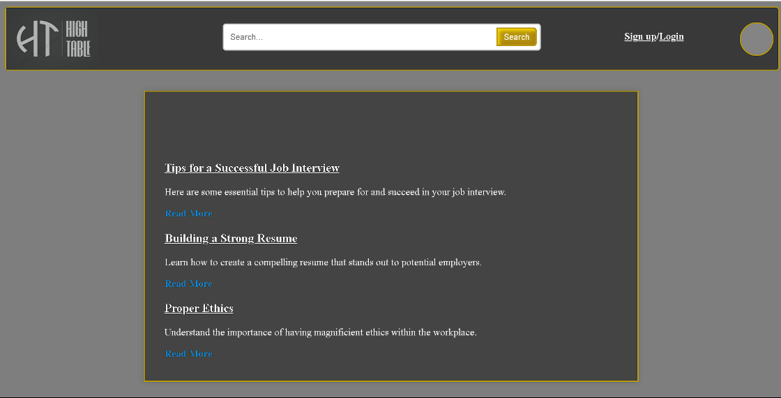**SCREEN SHOTS OF THE SOFTWARE/DATABASE:**

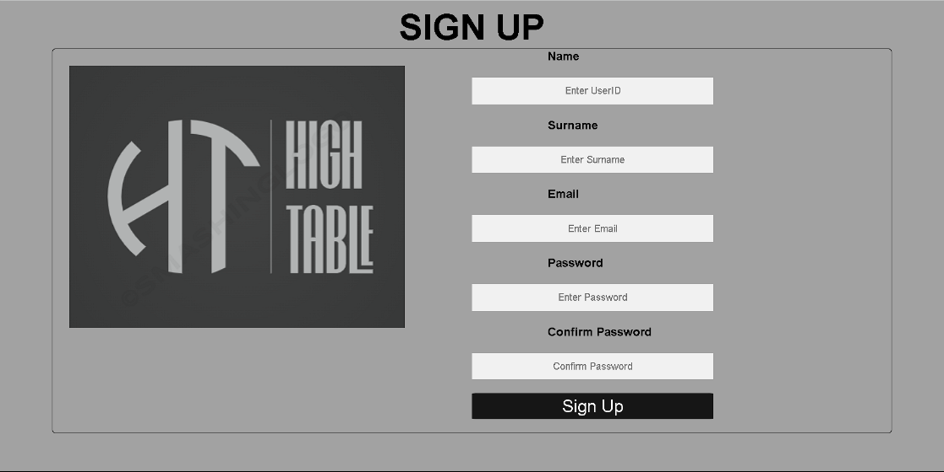

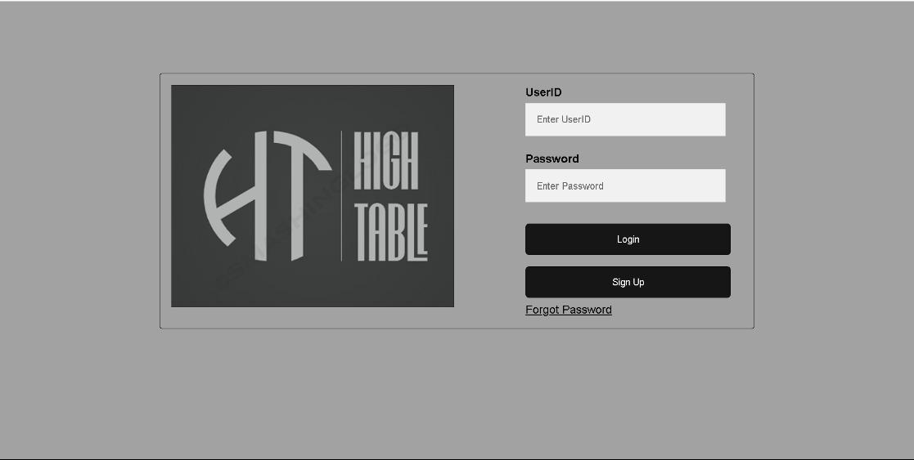

1. **CONCLUSION**

In conclusion, the journey of our group in creating High Table has been a remarkable and transformative experience. We embarked on this project with diverse skills and backgrounds, and through dedication and a shared vision, we handled the challenging process of developing High Table with success.

Together, we overcame obstacles, made discoveries, and came up with creative solutions that all assisted in our group's development. Through the process, we learned the value of clear objectives, flexibility, and excellent communication.

Our path demonstrates the strength of collaboration, perseverance, and the ability to learn and adapt to new concepts. We have not only developed High Table, but also a foundation of skills, knowledge, and unity that will definitely serve us well in future attempts. This experience has been about more than just developing High Table; it has been about developing a stronger, more capable team that is ready to take on future challenges and innovations.

High Table is a multifaceted platform that revolves around professional networking, career development and career advice. It empowers individuals to create a representation of their professional identity, connect with like-minded professionals, seek job opportunities, and engage in continuous learning and knowledge sharing.

High Table serves as a vital tool for career advancement, business growth, and industry awareness in the modern professional landscape.